**Vehicle Marketplace System**

**Introduction**

The purpose of our software system is an online marketplace in which users can freely buy and sell vehicles without the need for a middleman. It is aimed at people who want to sell their vehicles and it is intended to provide an easy platform for buyers and sellers to contact each other.

**General Description**

The system allows all users to browse an online marketplace of vehicles uploaded by other registered users and contact them via contact information provided with the advertisement by the seller. This allows an easy way for the buyer to browse cars, pick out a suitable one that fits all their personal criteria and get in contact with the seller.

**Requirements**

For the system to be successful it must have the following:

The system will have two types of users, new users and registered users.

New users can browse the marketplace and register a new account.

Users can log into their registered accounts.

Registered users can place advertisements with pictures, a description, and various relevant details about the vehicle including its type, mileage and engine size.

Registered users can contact sellers and review other registered users.

When browsing the marketplace, a filter can be applied to narrow the user’s search.

When registering an account users must first verify their details.

**User Stories**

|  |  |
| --- | --- |
| **Identifier** | US-001 |
| **Name** | Browse Marketplace |
| **Description** | As a buyer I want an intuitive way to browse cars for sale and filter my search results so that I can easily find cars for sale that fit my needs and budget. |
| **Acceptance Criteria** | 1. Advertisements can be viewed by other users. 2. Advertisements can be searched for by other users. 3. Filters can be applied to narrow the search criteria. |

|  |  |
| --- | --- |
| **Identifier** | US-002 |
| **Name** | Placing an Ad |
| **Description** | As a seller I want to be able to advertise my vehicle to many prospective buyers so that I can sell quickly and easily. |
| **Acceptance Criteria** | 1. Registered users can post at least three advertisements to the marketplace. 2. Advertisements contain up to ten images, all inputted vehicle details and corresponding seller details. 3. Posted advertisements are visible to all users on the marketplace. |

|  |  |
| --- | --- |
| **Identifier** | US-003 |
| **Name** | Sign-Up |
| **Description** | As a user I want to be able create an account so that I can save my information for when I need to interact with other users, contact other users and review other users |
| **Acceptance Criteria** | 1. A user can create an account with a username, name, address, password, email and phone number. 2. Registered User features become available once they have an account |

|  |  |
| --- | --- |
| **Identifier** | US-004 |
| **Name** | Login |
| **Description** | As a user I want to be able login so that I can save my information for when I need to interact with other users, contact other users and review other users |
| **Acceptance Criteria** | 1. A user can log-in using their email and password to become a registered user. 2. Registered User features become available once the user is logged in. |

|  |  |
| --- | --- |
| **Identifier** | US-005 |
| **Name** | Contact Seller |
| **Description** | As a buyer I want to be able to contact the seller of a car I am interested in so that I can arrange a viewing or payment for the car. |
| **Acceptance Criteria** | 1. Registered Users can send messages to other registered users. 2. Registered Users can receive messages from other registered users. |

|  |  |
| --- | --- |
| **Identifier** | US-006 |
| **Name** | Review User |
| **Description** | As a buyer I want to be able to review sellers I have dealt with so that I can let other people know if they are trustworthy. |
| **Acceptance Criteria** | 1. Registered Users can write reviews for other registered users who have posted advertisements in the past. 2. Registered Users can give a star rating of other registered users who have posted advertisements in the past. 3. Users can view reviews posted about other registered users. |

**Use Case Diagram**

**Scenario 1**

|  |  |
| --- | --- |
| **Use case name:** Browse Marketplace | **UniqueID:** UC-001 |
| **Area:** Vehicle Marketplace Website | |
| **Actor(s):** Users, Webstore | |
| **Description:** Users view the various vehicles for sale in the vehicle marketplace | |
| **Triggering Event:** User searches the marketplace with or without filters for a vehicle | |
| **Trigger type:** **External** **Temporal** | |
| **Steps Performed (Main Path)** | **Information for Steps** |
| 1. The user inputs a keyword to search for in the search bar | Search |
| 1. The user enters extra optional filters | Search |
| 1. The search is made for the items | Search, Marketplace |
| 1. The searched items are displayed | Search, Marketplace |
|  |  |
| **Preconditions:** The User is on the website and has searched for a vehicle | |
| **Postconditions:** The marketplace has displayed its listings for the user based on search | |
| **Assumptions:** There are ads to view | |
| **Requirements met:** Users can browse the marketplace | |
| **Outstanding issues:** | |
| **Priority:** High | |
| **Risk:** High | |

**Scenario 2**

|  |  |
| --- | --- |
| **Use case name:** Place Ad | **UniqueID:** UC-002 |
| **Area:** Vehicle Marketplace Website | |
| **Actor(s):** Registered User, Webstore | |
| **Description:** An ad is placed on the marketplace by a registered user | |
| **Triggering Event:** Registered User is on website and has clicked Place Ad | |
| **Trigger type:** **External** **Temporal** | |
| **Steps Performed (Main Path)** | **Information for Steps** |
| 1. Verify user is logged in / Allow user to log in | Current Session, RegUsers, LoginSignUp |
| 1. Allow user to enter details of ad | Advertisement, VehicleDetails, Image, SellerDetails, Seller |
| 1. Confirm contact details | Advertisement, Seller, SellerDetails |
| 1. Add advertisement to database and to user’s current ads | Advertisement, Marketplace, Seller |
| **Preconditions:** User is a Registered User and is logged in to the website | |
| **Postconditions:** Ad Database is updated to include new ad | |
| **Assumptions:** User is logged in | |
| **Requirements met:** Registered Users can place advertisements with pictures, a description, and various relevant details about the vehicle including its type, mileage, and engine size. | |
| **Outstanding issues:** | |
| **Priority:** High | |
| **Risk:** Medium | |

**Scenario 3**

|  |  |
| --- | --- |
| **Use case name:** Sign Up | **UniqueID:** UC-003 |
| **Area:** Vehicle Marketplace Website | |
| **Actor(s):** User | |
| **Description:** User registers an account for the website | |
| **Triggering Event:** User attempts to access a registered account only feature, or chooses to sign up | |
| **Trigger type:** **External** **Temporal** | |
| **Steps Performed (Main Path)** | **Information for Steps** |
| 1. User enters email for new account | User, LoginSignUp |
| 1. Verify email is not tied to existing account | LoginSignUp, RegUsers, RegisteredUser, Account |
| 1. New User enters remaining details of account | User, LoginSignUp |
| 1. Account is created and added to database | LoginSignUp, RegUsers, RegisteredUser, Account |
|  |  |
| **Preconditions:** User is not logged in | |
| **Postconditions:** New account has been created and current user is logged in automatically | |
| **Assumptions:** User wants to create account | |
| **Requirements met:** Users can register a new account | |
| **Outstanding issues:** | |
| **Priority: High** | |
| **Risk: High** | |

**Scenario 4**

|  |  |
| --- | --- |
| **Use case name:** Log In | **UniqueID:** UC-004 |
| **Area:** Vehicle Marketplace Website | |
| **Actor(s):** User, Webstore | |
| **Description:** User logs in to their account | |
| **Triggering Event:** User attempts to access a Registered User Only feature while not logged in, or User chooses to log in | |
| **Trigger type:** **External** **Temporal** | |
| **Steps Performed (Main Path)** | **Information for Steps** |
| 1. User enters their account details | User, LoginSignUp |
| 1. System checks if account exists | LoginSignUp, RegUsers, RegisteredUser, Account |
| 1. Updates User to Registered User | User, RegisteredUser, LoginSignUp |
| 1. Returns to previous page, logged in. |  |
|  |  |
|  |  |
| **Preconditions:** User is not logged in, and wishes to be logged in | |
| **Postconditions:** User is logged in, becomes Registered User | |
| **Assumptions:** User is not logged in, and wishes to | |
| **Requirements met:** Users can log into their registered accounts | |
| **Outstanding issues:** | |
| **Priority: High** | |
| **Risk: Medium** | |

**Scenario 5**

|  |  |
| --- | --- |
| **Use case name:** Contact Seller | **UniqueID:** UC-005 |
| **Area:** Vehicle Marketplace Website | |
| **Actor(s):** Registered User, Webstore | |
| **Description:** RegisteredUser contacts seller of ad they are interested in | |
| **Triggering Event:** RegisteredUser finds ad they are interested in | |
| **Trigger type:** **External** **Temporal** | |
| **Steps Performed (Main Path)** | **Information for Steps** |
| 1. Seller ID is acquired from the Ad | RegisteredUser, Advertisement |
| 1. User enters message for seller | RegisteredUser , Advertisement, Message |
| 1. Chat is created between user and seller | RegisteredUser, ChatLog |
| 1. Message is sent to seller | ChatLog, Message, RegisteredUser |
|  |  |
|  |  |
| **Preconditions:** User has found appropriate ad | |
| **Postconditions:** User has contacted seller of ad | |
| **Assumptions:** Buyer wishes to contact seller of the ad, and buyer is logged in. | |
| **Requirements met:** Registered users can contact sellers. | |
| **Outstanding issues:** | |
| **Priority: High** | |
| **Risk: Medium-High** | |

**Scenario 6**

|  |  |
| --- | --- |
| **Use case name:** Review User | **UniqueID:** UC-006 |
| **Area:** Vehicle Marketplace Website | |
| **Actor(s):** Registered User, Webstore | |
| **Description:** Registered User leaves review for seller/buyer | |
| **Triggering Event:** Registered User has contacted a seller/been contacted by a buyer | |
| **Trigger type:** **External** **Temporal** | |
| **Steps Performed (Main Path)** | **Information for Steps** |
| 1. Verify user is registered and logged in |  |
| 1. Verify Buyer and Seller have been in contact | RegisteredUser, Account, ChatLog, Message |
| 1. User chooses star rating | RegisteredUser, Review |
| 1. User fills in information within review | RegisteredUser, Review |
| 1. Review is added to seller’s account | Review, RegisteredUser, Account, RegisteredUser |
|  |  |
| **Preconditions:** Registered User and seller/buyer have contacted each other | |
| **Postconditions:** Created review appears on reviewed users account and in DB | |
| **Assumptions:** Buyer has purchased item from reviewed user. Buyer is logged in. | |
| **Requirements met:** Registered Users can review other registered users. | |
| **Outstanding issues:** | |
| **Priority:** Medium | |
| **Risk:** Low | |

**Sequence Diagram – UC-001 Browse Marketplace**

* **Message Analysis Table**

|  |  |  |  |  |  |  |
| --- | --- | --- | --- | --- | --- | --- |
| **Sequence Num** | **Caller** | **Callee** | **Msg Name** | **Msg Type** | **Msg Param** | **Msg Constraints** |
| 1 | User | Search | Search | Syn | Keyword |  |
| 2 | Search | User | ExtraFilters | Syn | - |  |
| 3 | User | Search | Filter | Syn | vehicleDetails |  |
| 4 | User | Search | Confirm | Syn | - |  |
| 5 | Search | Marketplace | ApplySearch | Syn | Keyword, vehicleDetails |  |
| 6 | Marketplace | User | Display | Syn | Ad[] |  |

**Sequence Diagram – UC-002 Place Ad**

|  |  |  |  |  |  |  |
| --- | --- | --- | --- | --- | --- | --- |
| **Sequence Num** | **Caller** | **Callee** | **Msg Name** | **Msg Type** | **Msg Param** | **Msg Constraints** |
| 1 | RegisteredUser | Advertisement | PlaceAd | Syn | - |  |
| 2 | Advertisement | RegisteredUser | RequestDetails | Syn | - |  |
| 3 | RegisteredUser | Advertisement | Enter  Details | Syn | Details |  |
| 4 | Advertisement | VehicleDetails | Create  Details | Syn | Details |  |
| 5 | Advertisement | RegisteredUser | RequestImages | Syn | - |  |
| 6 | RegisteredUser | Advertisement | Enter  Images | Syn | Image |  |
| 7 | Advertisement | Image | create | Syn | - |  |
| 8 | RegisteredUser | Advertisement | postAd | Syn | - |  |
| 9 | Advertisement | Marketplace | display | Syn | advertisement |  |

* **Message Analysis Table**

**Sequence Diagram – UC-003 Sign Up**

|  |  |  |  |  |  |  |
| --- | --- | --- | --- | --- | --- | --- |
| **Sequence Num** | **Caller** | **Callee** | **Msg Name** | **Msg Type** | **Msg Param** | **Msg Constraints** |
| 1 | User | LoginSignUp | Register | Syn | Username, password, email |  |
| 2 | LoginSignUp | RegUsers | confirmUniqueDetails | Syn | Username, email |  |
| 3 | RegUsers | LoginSignUp | INVALID | Syn | - |  |
| 4 | LoginSignUp | User | rerequestDetails | Syn | Type |  |
| 5 | RegUsers | LoginSignUp | VALID | Syn | - |  |
| 6 | LoginSignUp | User | requestMore  Details | Syn | - |  |
| 7 | User | LoginSignUp | provideDetails | Syn | Address, phone, confPass, confEmail |  |
| 8 | LoginSignUp | RegisteredUser | Create  Account | Syn | Username, password, email, address, phone |  |
| 9 | RegisteredUser | Account | Create  Account | Syn | Username, password, email, address, phone |  |
| 10 | RegisteredUser | RegUsers | addedTo | Syn | - |  |

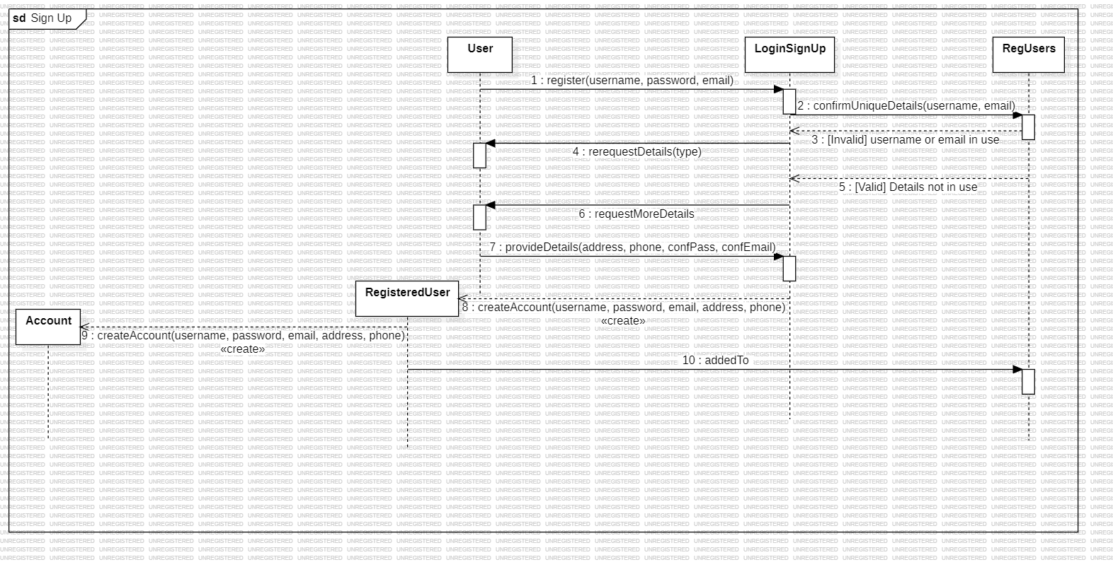

* **Message Analysis Table**

**Sequence Diagram – UC-004 Log In**

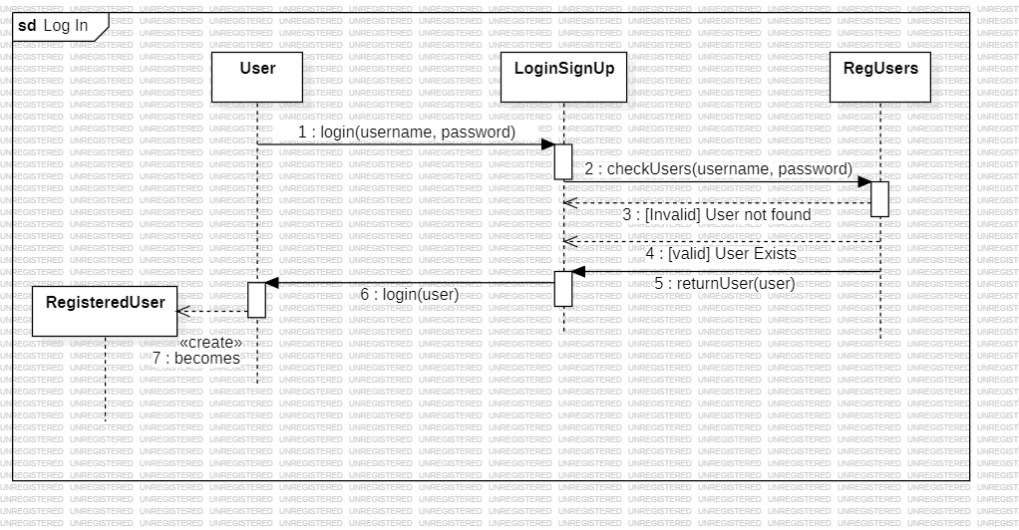

|  |  |  |  |  |  |  |
| --- | --- | --- | --- | --- | --- | --- |
| **Sequence Num** | **Caller** | **Callee** | **Msg Name** | **Msg Type** | **Msg Param** | **Msg Constraints** |
| 1 | User | LoginSignUp | giveDetails | Syn | Username, password |  |
| 2 | LoginSignUp | RegUsers | checkUsers | Syn | Username, password |  |
| 3 | RegUsers | LoginSignUp | INVALID | Syn | - |  |
| 4 | RegUsers | LoginSignUp | VALID | Syn | - |  |
| 5 | RegUsers | LoginSignUp | returnUser | Syn | User |  |
| 6 | LoginSignUp | User | Login | Syn | User |  |
| 7 | User | RegisteredUser | becomes | Syn | - |  |

* **Message Analysis Table**

**Sequence Diagram – UC-005 Contact Seller**

|  |  |  |  |  |  |  |
| --- | --- | --- | --- | --- | --- | --- |
| **Sequence Num** | **Caller** | **Callee** | **Msg Name** | **Msg Type** | **Msg Parameters** | **Msg Constraints** |
| 1 | RegisteredUser | Advertisement | requestSellerID | Syn |  | - |
| 2 | Advertisement | Advertisement | getSellerID | Syn |  | - |
| 3 | Advertisement | RegisteredUser | SendID | Syn | ID | - |
| 4 | RegisteredUser | ChatLog | createChat | Syn | buyerID, sellerID | - |
| 5 | RegisteredUser | Message | createMessage | Syn | text, buyerID | - |
| 6 | RegisteredUser | ChatLog | send | Syn | message | - |
| 7 | ChatLog | RegisteredUser | sent | Syn | message | - |
| 8 | RegisteredUser | RegisteredUser | view | Syn | chatlog | - |
| 9 | RegisteredUser | Message | createMessage | Syn | text, sellerID | - |
| 10 | RegisteredUser | ChatLog | send | Syn | message | - |

* **Message Analysis Table**

**Sequence Diagram – UC-006 Review User**

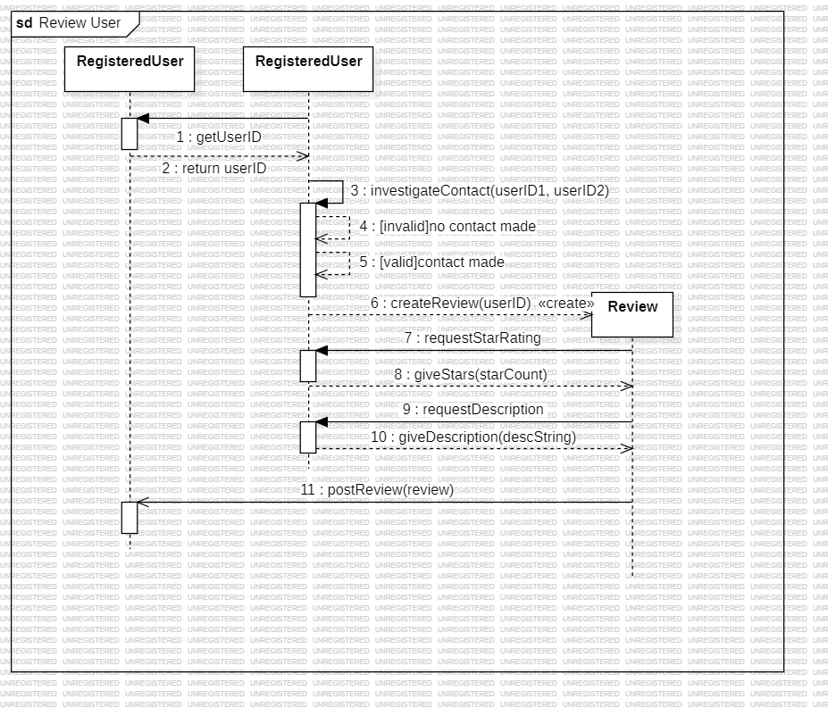

* **Message Analysis Table**

|  |  |  |  |  |  |  |
| --- | --- | --- | --- | --- | --- | --- |
| **Sequence Num** | **Caller** | **Callee** | **Msg Name** | **Msg Type** | **Msg Parameters** | **Msg Constraints** |
| 1 | RegisteredUser1 | RegisteredUser2 | getUserID | Syn | - | - |
| 2 | RegisteredUser2 | RegisteredUser1 | return | Syn | userID | - |
| 3 | RegisteredUser1 | RegisteredUser1 | investigateContact | Syn | userID1, userID2 | - |
| 5 | RegisteredUser1 | RegisteredUser1 | contactMade | Syn | - | [valid] |
| 6 | RegisteredUser1 | Review | createReview | Syn | userID2 | - |
| 7 | Review | RegisteredUser1 | requestStarRating | Syn | - | - |
| 8 | RegisteredUser1 | Review | giveStars | Syn | starCount | - |
| 9 | Review | RegisteredUser1 | requestDescription | Syn | - | - |
| 10 | RegisteredUser1 | Review | giveDescription | Syn | descString | - |
| 11 | Review | RegisteredUser2 | postReview | Syn | review | - |

**Test Case TC-001 Browse Marketplace**

|  |  |
| --- | --- |
| Name | TC-001(verify ads can be viewed and searched for on the marketplace) |
| Requirements | A way to display ads to other users |
| Preconditions | User is logged in; testAd has been loaded into the Ad Database |
| Steps | 1. Enter a “testAd” into the search bar. 2. Apply filters that correspond with the vehicle details contained in “testAd.” 3. Click confirm |
| Expected Result | 1. Verify that the “testAd” is displayed on the marketplace. 2. Verify that “testAd” contains the correct vehicle details. 3. Verify that “testAd” contains the correct image. |

**Test Case TC-002 Place Ad**

|  |  |
| --- | --- |
| Name | TC-002 (verifying that the user can create an advertisement and it is uploaded to the marketplace) |
| Requirements | Registered users can place advertisements on the marketplace with pictures, a description, and specific details to be viewed by other registered users |
| Preconditions | Test user is logged in |
| Steps | 1. Click on place ad button. 2. Click on title field. 3. Enter “testAd”. 4. Click on upload images. 5. Upload “testImage.png”, “testImage2.jpg”. 6. Click on each detail field. 7. Enter the appropriate details as outlined in “test_vehicle.docx” 8. Click submit ad button. |
| Expected Result | 1. The ad is posted to the ad database. 2. Verify that the ad can be found via a search of the marketplace. 3. Verify that the images and details are present exactly as outlined in the creation of the ad. |

**Test Case TC-003 Sign Up**

|  |  |
| --- | --- |
| Name | TC-003 (verifying that the user can create an account and it is added to the registered users’ database) |
| Requirements | New users can register a new account |
| Preconditions | No user is logged in |
| Steps | 1. Click on the Log In button. 2. Click the “Not a member? Sign Up!” text 3. Click the detail fields. 4. Enter the details as outlined in TEST_ACCOUNT_FAIL.docx 5. Click Create Account button 6. Replace the details with those outlined in TEST_ACCOUNT_PASS.docx 7. Click the Create Account button |
| Expected Result | 1. The Create Account button creates an error message, stating the email and password are in use 2. Verify that the account is added to the RegUsers database upon creation. 3. Verify that the account details are exactly as specified in account creation. |

**Test Case TC-004 Log In**

|  |  |
| --- | --- |
| Name | TC-003 (verifying that the user can log into a created account) |
| Requirements | Users can log into their registered accounts |
| Preconditions | User is not logged in |
| Steps | 1. Click on Log In button 2. Click on Username field 3. Enter “TestUser00001” 4. Click on Password field 5. Enter “Qn8##4Bkk-sR9” 6. Click on Log In |
| Expected Result | 1. The user is returned to the home page, logged into their account. 2. Verify that the account logged into matches the description found in ADMIN_ACCOUNT_DETAILS.docx |

**Test Case TC-005 Contact Seller**

|  |  |
| --- | --- |
| Name | TC-005 (Verifying that registered users can contact sellers of advertisements) |
| Requirements | Registered Users can contact sellers. |
| Preconditions | TestUser00002 is logged in, viewing TestAd001 |
| Steps | 1. Click on Contact Test 2. Click Message field 3. Type “This is a test message” 4. Click Send Message |
| Expected Result | 1. The Message is sent to TestUser00001 2. Verify that TestUser00002 has a chatlog with TestUser00001 3. Verify that TestUser00001 received the intended message from TestUser00002 |

**Test Case TC-006 Review User**

|  |  |
| --- | --- |
| Name | TC-006 (Verifying that a registered user can create a review for a user they have been in contact with) |
| Requirements | Registered users can review other registered users. |
| Preconditions | TestUser00001 is logged in and has been in contact with TestUser00002 |
| Steps | 1. Click on Account button 2. Click on Messages 3. Click on TestUser00002 chatlog 4. Click on TestUser00002’s profile 5. Click on Leave Review 6. Click on the Fourth Star 7. Click the Description field. 8. Enter “This is a test review.” 9. Click on Leave Review |
| Expected Result | 1. Verify that the review is present on TestUser00002’s profile. 2. Verify that the review’s star rating and description match those on TestUser00002’s profile. |

**Credits**

Requirements: Diarmuid 100%

Use Case Diagram: Stuart 50%, Diarmuid 50%

Scenario Spec Sheets: Stuart 100%

Class Diagram: Diarmuid 90%, Stuart 10%

Sequence Diagram: Stuart 50%, Diarmuid 50%

Message Analysis Tables: Stuart 60%, Diarmuid 40%

Test Cases: Diarmuid 50%, Stuart 50%